**Neha Malhotra**  **R.L. Institute M: 9416974837**

**Max Time : 1 ½ hr** **Class = 12th Biology Test**  **Max Marks : 40**

**HUMAN REPRODUCTION**

1. Multiple choice Questions: [ 1 x 10 = 10 ]
2. Given below are the structural details of a human mammary gland. Choose the correct options :
3. The glandular tissue in the breast has 15 – 20 clusters of cells called alveoli.
4. The milk is stored in the lumen of alveoli.
5. The alveoli join to form the mammary ducts.
6. Mammary ampulla is connected to lactiferous ducts.

|  |  |  |  |
| --- | --- | --- | --- |
| a) (i) and (ii) | b) (ii) and (iii) | c) (ii) and (iv) | d) (i) and (iii) |

1. The uterus opens into the vagina through a narrow structure called :

|  |  |  |  |
| --- | --- | --- | --- |
| a) Ampulla | b) isthmus | c) cervix | d) infundibulum |

1. Penetration of the sperm in the ovum is followed by :

|  |  |
| --- | --- |
| a) formation of 1st polar body | b) completion of meiosis – II |
| c) first meiosis | d) Dissolution of zona pellucida |

1. The correct sequence of hormone secretion from beginning of menstruation is :

|  |  |
| --- | --- |
| a) FSH , Progesterone , estrogen | b) Estrogen , FSH , Progesterone |
| c) FSH , estrogen , progesterone | d) Estrogen , progesterone , FSH |

1. Nebenkern is a part of :

|  |  |  |  |
| --- | --- | --- | --- |
| a) Foetus | b) ovum | c) sperm | d) graafian follicle |

1. Embryo at 16-32 cell stage is called :

|  |  |  |  |
| --- | --- | --- | --- |
| a) blastula | b) morula | c) trophoblast | d) inner cell mass |

1. Which of the following hormones have very important role in lactation?

|  |  |
| --- | --- |
| a) Estrogen and progesterone | b) Progesterone and testosterone |
| c) LH and FSH | d) Oxytocin and prolactin |

**Assertion-Reason Type Questions**

**DIRECTIONS :** In each of the following questions, a statement of Assertion (A) is given followed by a corresponding statement of Reason (R) just below it. Of the statements, mark the correct answer as:

1. If both assertion and reason are true, but reason is the true explanation of the assertion.
2. If both assertion and reason are true, but reason is not the true explanation of the assertion.
3. If assertion is true, but reason is false.
4. If both assertion and reason are false.
5. **Assertion:** Interstitial space outside the seminiferous tubules have blood vessels and Sertoli cells.

**Reason:** Sertoli cells provide nutrition to the germ cells.

1. **Assertion:** Before fusion, spermatozoa has to penetrate egg membrane.

**Reason:** The activated spermatozoa undergo acrosomal reactions and release sperm lysin.

1. **Assertion:** Parturition is induced by a complex neuroendocrine mechanism.

**Reason:** At the end of the pregnancy, the maternal pituitary release prolactin which causes uterine contractions.

1. Define capacitation. [ 1 ]
2. Write the location and functions of each of the following : [ 2 ]

(i) Sertoli cells (ii) Leydig cell

1. Name and explain the role of inner and middle walls of human uterus. { 2 ]
2. Mention the fate of corpus luteum during fertilization and its effect on the uterus in the absence of fertilization of the ovum in human female. [ 2 ]
3. The graph below shows the number of primordial follicles per ovary in women at different ages. Study the graph and answer the questions that follows. [ 2 ]

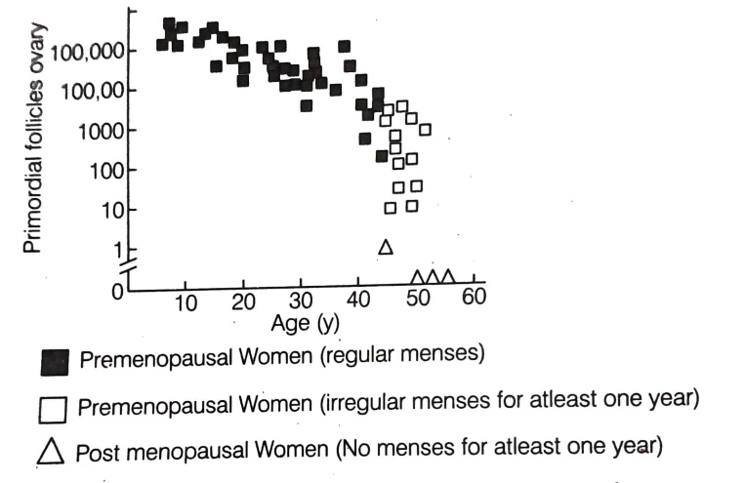

1. What is the average rate of the women at the onset of menopause?
2. At what age are maximum primordial follicles present in an ovary, according to the given graph?
3. When and where do chorionic villi appear in humans? State their function. [ 2 ]
4. (i) Where do the signals for parturition originate in humans? [ 2 ]

(ii) Why it is important to feed the new born babies on colostrum?

1. Spermatogenesis in human males is a hormone regulated process. Justify. [ 3 ]
2. The following is the illustration of the sequence of ovarian events A – I in a human female. [ 4 ]

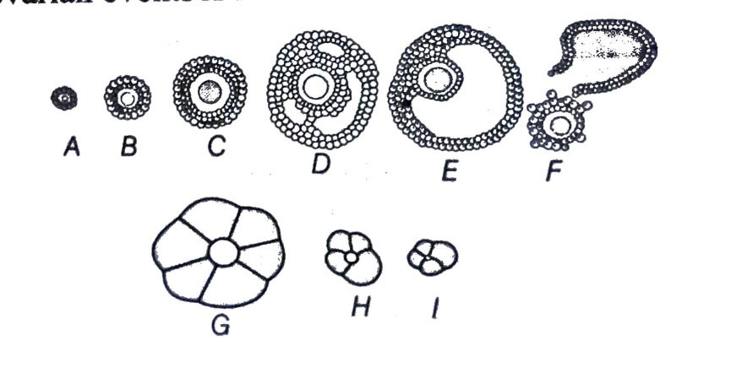

1. Identify the figure that illustrates corpus luteum and name the pituitary hormone that influences its formation.
2. Specify the endocrine function of corpus luteum. Hoe does it influence the uterus? Why is it essential?
3. What is the difference between C and E?
4. Draw a neat and labelled sketch of Graafian follicle.
5. (i) Explain the formation of placenta after the implantation in a human female. [ 5 ]

(ii) Draw a diagram showing human foetus within the uterus and label any four parts in it.

1. (i) Draw a diagram of the adult human female reproductive system and label the different: [ 5 ]

(a) Parts of fallopian tubes (b) layers of uterus wall

(ii) Explain the events during fertilization of an ovum in humans.